**NAME: Arvind Ravi REG NO: 230701038**

**EXP NO :03**

**DATE :10/08/2024**

WRITING BASIC SQL SELECT STATEMENTS.

Find the Solution for the following:

True OR False

1. The following statement executes successfully. Identify the Errors

SELECT employee_id, last_name sal*12 ANNUAL SALARY FROM

employees;

Queries

SELECT employee_id, last_name, sal*12 AS ANNUAL_SALARY FROM employees;

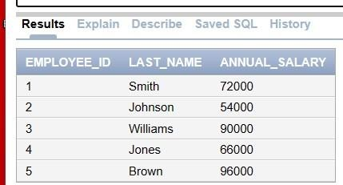

1. Show the structure of departments the table. Select all the data from it. DESCRIBE department;

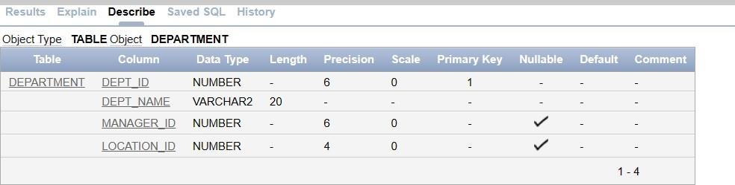

1. Create a query to display the last name, job code, hire date, and employee number for each employee, with employee number appearing first.

SELECT employee_id, last_name, job_code, hire_date FROM employees;

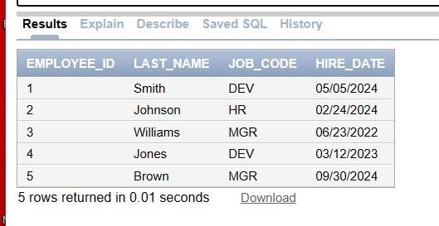

1. Provide an alias STARTDATE for the hire date.

SELECT employee_id, last_name, job_id, hire_date AS STARTDATE FROM employees;

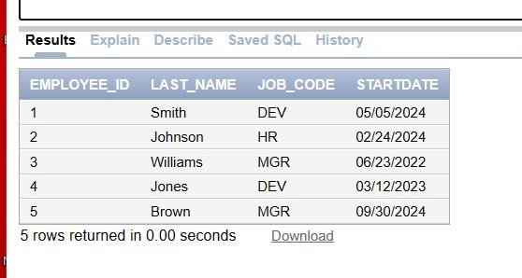

1. Create a query to display unique job codes from the employee table. SELECT DISTINCT job_code

FROM employees;

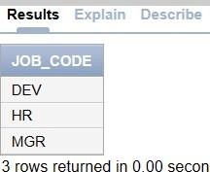

1. Display the last name concatenated with the job ID , separated by a comma and space, and name the column EMPLOYEE and TITLE.

SELECT last_name || ', ' || job_code AS EMPLOYEE_AND_TITLE FROM employees;

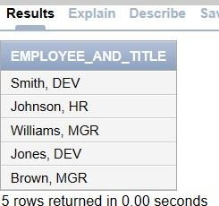

1. Create a query to display all the data from the employees table. Separate each column by a comma. Name the column THE_OUTPUT.

SELECT employee_id || ',' || last_name || ',' || job_code || ',' || TO_CHAR(hire_date, 'YYYY-MM- DD') AS THE_OUTPUT

FROM employees;

